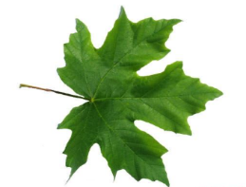
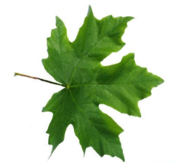
*Go on a walk and keep a tally of all the bugs you find. Make sure to be careful when lifting logs and stones!
With help from an adult, create a small bug hotel using natural materials (sticks, leaves, stones).
Take a picture or draw it.
Explain which creatures might use it.

Maple class homework – Summer 2026
*Go on a mini adventure in your garden, local park, or outdoor space.
Can you find 2 different microhabitats (e.g. under a rock, in grass, under leaves)?
Draw what you find and label any creatures you see.

Find two microhabitats (e.g. grass and under a stone).
How are they different?
Write or draw 2 differences (e.g. wet/dry, light/dark).

Homework guidance for Children, Parents and Carers- Alongside daily reading, throughout the next term you have been asked to complete as many of the above activities as possible! The activities marked with an * are deemed compulsory, the others are recommended activities to further children’s understanding, and deepen their engagement with, the current learning topic. We strongly encourage that any completed homework is brought into class to be acknowledged, and celebrated. always, if you require any additional resources, please let us know and we will aim to provide these. Thank you for your support.
*Write an acrostic poem about a creature you may find under a log!
Remember to use expanded noun phrases to make your poem more interesting!
Carefully lift a leaf or small log (with an adult).
What do you notice underneath?
Write a sentence or two about what you saw and why animals might like living there.

*Have a go in TT rockstars!
Try the 2, 5, 10 and 3’s!
Write a short story about a small animal (like an ant or beetle).
Where does it live? What does it find in its microhabitat?

