Oak Class Homework
Using your research skills, look up the artist William Morris and design your own wallpaper pattern. You can use the motifs attached to the homework sheet. First, choose some motifs to use in your design.
Then, experiment with the placement of the motifs (You can rotate and repeat them!) when you are happy either trace or draw the motif.
Remember - William Morris used repeated patterns and symmetry in his designs.
Finally, decide on your colour scheme. Try to keep it simple - William Morris usually only used two or three different colours
Remember the patterns are repeating and symmetrical!
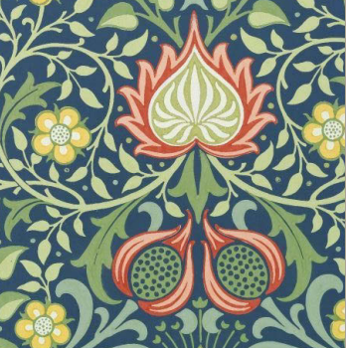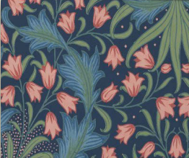

Imagine it is the 28th June 1838. You are Queen Victoria on her Coronation day which is taking place at Westminster Abbey.
Write a Diary entry – either before her coronation, or a short recount of her special day.
Autumn Term 2023
Draw an electrical circuit using the correct scientific symbols?
The circuit must include a cell, a bulb, a buzzer and a motor.
Can you remember the difference between a battery and a cell?

Awesome Engineers!
What is my number?
Be creative mathematicians and write your own number puzzle.
I’m thinking of a number.
If I add 45 and then divide by 10, I’ll get the answer 13.
What number am I thinking of?
*Be awesome Historians and research information about Isambard Kingdom Brunel, then create a fact file all about him (you can use bullet points).
Feel free to use these subheadings to help!
Early Life
Family
Achievements


Homework guidance for Children, Parents and Carers.
Alongside daily reading and weekly spelling practice throughout the next term you have been asked to complete as many of the above activities as possible! The activities marked with *are deemed compulsory, the others are recommended activities to further children’s understanding, and deepen their engagement with the current learning topic. We strongly encourage that any completed homework is brought into class to be acknowledged and celebrated with peers at the end of term to promote a sense of pride and achievement. All homework completed will be monitored and house points will be rewarded; children who complete all pieces of homework throughout the term will be entered into a class prize draw!
*You will find your weekly spellings in your reading log book and we will test you on a Tuesday the following week.

Using the template, create a word search based on the theme of ‘Electricity’ (You can research some amazing words to use) and you can share it with the class to complete.

