Rowan Class- English Home Learning- Macbeth
Week 3
“Daggers for King Duncan”
https://www.bbc.co.uk/teach/school-radio/english-ks2-macbeth-3/znjvscw
Activity 1
Watch Clip 3 up to 2.43 mins and then read this simplified version of Scene 7 of the original play script by Shakespeare:
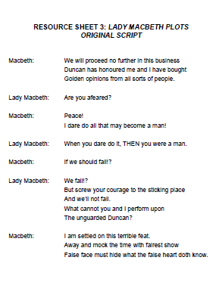

What do you think the following words and phrases mean?
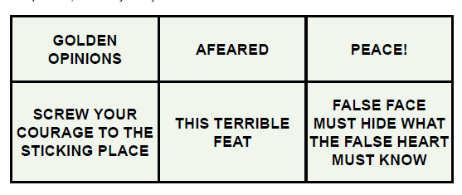

Activity 2
Create a comic-strip version of the dialogue between Macbeth and Lady Macbeth.
You can use the extract in Activity 1 as well as Clip 2 up to 1.41 mins to help you write your comic-strip, as well as your own ideas.

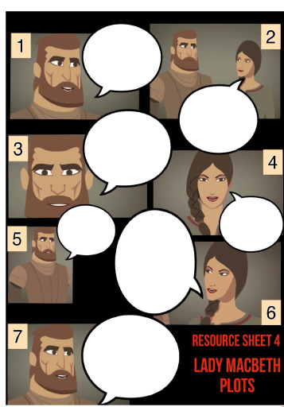
Activity 3
Watch Clip 3 from 2.43 mins to the end. Then read Macbeth pages 26-31.
Questions:
- Macbeth is being driven to murder by a strange force and cannot be held responsible for his actions. Do you agree? Look at pages 26-27 for evidence from the text.
- Can you find an example of personification on p.28?
- Read to the end of p.30. Why do you think that Macbeth has two daggers?
- What does Lady Macbeth do to make the guards seem guilty of Duncan’s murder?
- On page 30, why does Lady Macbeth say, “You should not have brought the daggers here!”?
- What words and phrases on pages 30 and 31 suggest that Macbeth feels guilty about what he has done?
Activity 4
Watch Clip 4 – “All Hail Macbeth, King of Scotland!” up to 2.00mins. Then read pages 32-34.
Questions:
- Why do you think people suspect Malcom and Donalbain of murdering King Duncan?
- Why do you think that Malcom and Donalbain are convinced that Macbeth is the murderer?
- After their father’s murder, where do Malcom and Donalbain go?
- Write a summary of pages 26-34 in six sentences.

Activity 5
- Read p.35. How do you think Macbeth will get rid of Banquo and his son Fleance?
- Now- Watch Clip 4 from 2.00 mins to the end. Were you right? What is Macbeth’s plan?
- Replace the words in bold with synonyms: (use a thesaurus or https://www.collinsdictionary.com/dictionary/english-thesaurus to help)
Without realising, the strange force that had compelled Lady Macbeth and Macbeth to kill Duncan was slowly driving them apart.

