ACTIVITY 5- INVESTIGATING DISSOLVING
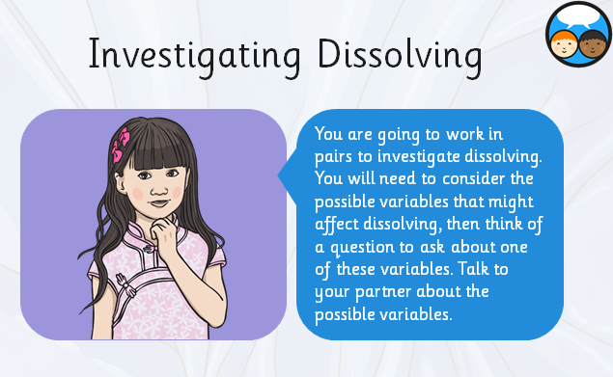

How many variables can you think of?
- Time stirred
- Speed of stirs
- Water temperature
- Number of stirs
- Mass of material
- Time to dissolve
- Type of water
- Type of container
- Particle size

