ACTIVITY 1- PROPERTIES OF MATERIALS

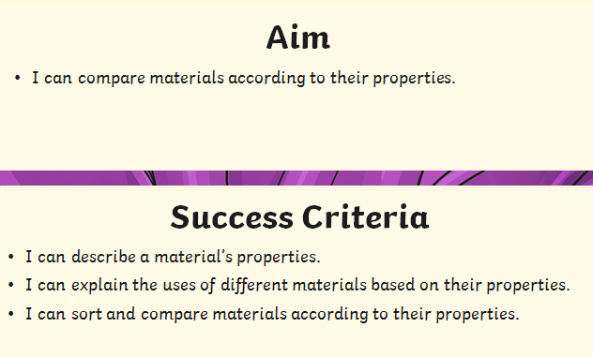

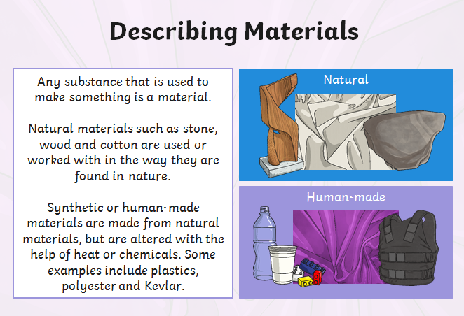

Ask your parent to put a variety of objects made from different materials from around your house into a bag.
Can you identify the materials without looking at them?
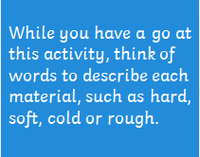
Now look inside the bag…
