Rowan Class English- Macbeth
Week 2- 27th April- 1st May
Good Morning Rowan Class!
Here are your English activities for this week. If you have any problems accessing the resources or have any queries, please let me know.
I will also upload this document and the accompanying resources sheets to our page on the website.
Hope you all have a great week!
Best wishes from Mrs Cook

Watch Clip 2- ‘All Hail Macbeth Thane of Cawdor’ and read pages- 16-25 of Macbeth.
https://www.bbc.co.uk/teach/school-radio/english-ks2-macbeth-2/zvmr382
Activity 1
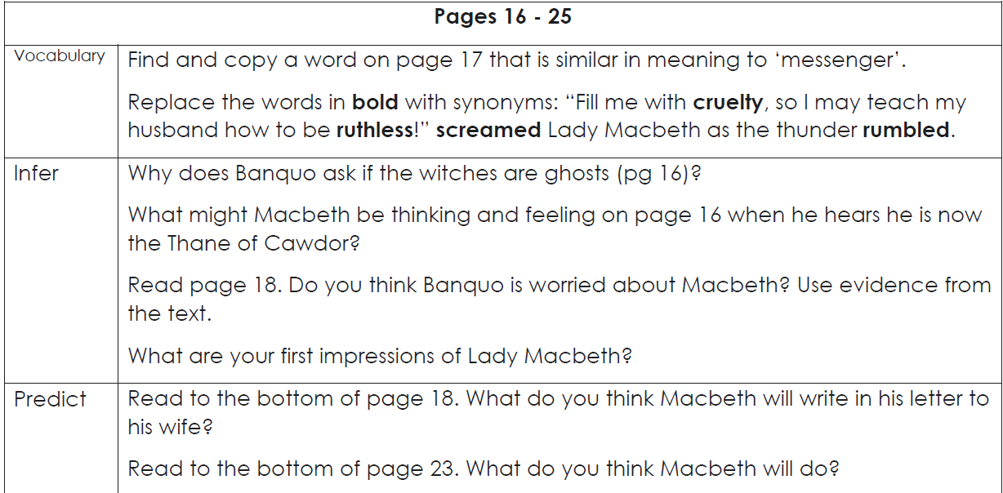

Activity 2
By now, we have learned quite a lot about Macbeth and Lady Macbeth. Create a ‘role on the wall’ for each of them- using the outline sheets. Inside the figures, write down your ideas about their personality and also their hopes, fears and dreams. On the outside of the figures, add information about their physical appearance and what other people think about them.
For example, Macbeth:
Inside the figure: (Personality, hopes, dreams, worries)
- Worried about the witches’ predictions
- Thinks he would make a good king because he is a brave, courageous warrior
- Worried that Banquo’s sons will be kings- why not his sons?
- Worried about Malcom (Duncan’s son) becoming his heir to the throne- will Malcom stand in his way?
- Devoted to his wife, Lady Macbeth

Outside the figure: (Physical appearance/What other people think of him)
- Tall and broad-shouldered
- A warrior’s face- has a broken nose and battle scars
- King Duncan thinks highly of him- has made him Thane of Cawdor
- His wife, Lady Macbeth thinks he is too soft-hearted to do what he must to become king (ie: kill King Duncan).

Activity 3
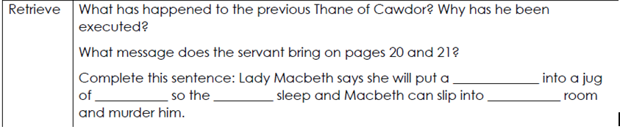

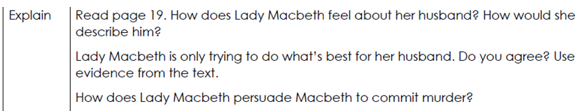

Activity 4
Reread pages 12-18. Imagine that you are Banquo. Write a diary entry, summarising the events on pages 12-18. Remember to use the first person and write in the past tense.

Activity 5
In Scene 5 of the original play by Shakespeare, Lady Macbeth gives the following advice to Macbeth:
Your face, my thane, is as a book where men
May read strange matters. To beguile the time,
Look like the time. Bear welcome in your eye,
Your hand, your tongue, look like th' innocent flower,
But be the serpent under ’t.

What do you think she is trying to tell him?
Can you summarise her advice by rewriting it in modern- day language?
I have given you an example below…
You find it hard to hide your feelings; your face always gives you away, so people can read you like a book. In order to trick everyone this evening, you need to look pleased and proud that the King has come to visit you. You must be relaxed and act normally.
When you greet the king, you must be welcoming and charming; pretend that you are honoured that he is staying with you, so that no-one suspects anything. In other words, you need to look like an innocent flower, but secretly be as cunning as the snake that hides underneath the flower.
SPaG (Spelling, Punctuation and Grammar) activities for this week…
BBC Bitesize:
https://www.bbc.co.uk/bitesize/tags/zhgppg8/year-5-lessons/1

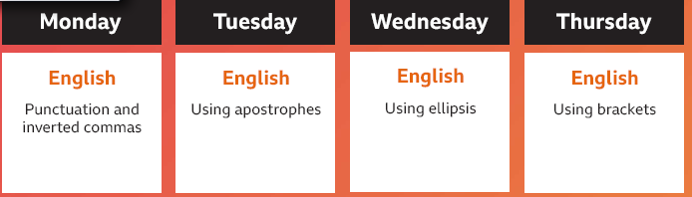
Oak National Academy:
https://www.thenational.academy/online-classroom/year-5/
Thursday
