Rowan Class Home Learning
29.6-3.7.20
English- “A Midsummer Night’s Dream”
Activity 1
Read pages 16-22. Then watch Clip 3- “Into the Woods”:
https://www.bbc.co.uk/programmes/p081xtg6
(Up to 02.48 mins)
- Find and copy a word on page 16 that means the same as ‘argued’.
- Why is Oberon jealous (pg 16)?
- Can you find a simile on page 17 and explain what it means?
- How is Titania feeling when Oberon appears on page 17?
- What do the verbs ‘snapped’ and ‘hissed’ tell you about how Oberon and Titania are feeling on pages 18 and 19?
- Underline a word on page 19 that tells us the blue fire is very powerful.
- Read to the end of page 21. What will Oberon do with the magic flower? Read to the end of page 22. Who do you think is approaching?
Activity 2
- Use the information on page 21 to draw and label a picture of Puck. What does Oberon ask Puck to find and bring him?
- Shakespeare describes Puck as ‘that merry wanderer of the night’ and a ‘shrewd and knavish sprite’. What might this mean? What do these quotes tell you about Puck’s personality?
- Summarise Oberon’s plan on page 22 in three sentences.

Activity 3
Read pages 23-26. Then watch the rest of Clip 3 (02.50mins to end)
- Find and copy a word on page 23 that means the same as ‘stopped’.
- What might Helena be thinking and feeling on page 23 when Demetrius tells her to go home?
- Why does Oberon want to help Helena (pg 25)?
- Read to the end of page 25. What do you think the ‘glimmering, white flowers’ are?
- Oberon is wrong to interfere. Do you agree? Disagree? Why?
- What advice would you give to Helena? Write a letter to her explaining what you think she should do and why.

Activity 4
Watch Clip 4: “The Wrong Athenian”:
https://www.bbc.co.uk/programmes/p081xthg
Then read pages 27-33.
- Replace the words in bold with synonyms: Oberon dropped juice from the magic flowers on to Titania’s eyelids whilst murmuring a spell.
- Puck has given the magic juice to Lysander and Helena. True or false?
- Who is the first person Lysander sees when he wakes up on page 30?
- Complete this sentence: Lysander says Helena’s eyes are like ________ and her hair is as ________ as ravens’ _________.

Read this dialogue between Demetrius and Helena, from the playscript by Shakespeare:
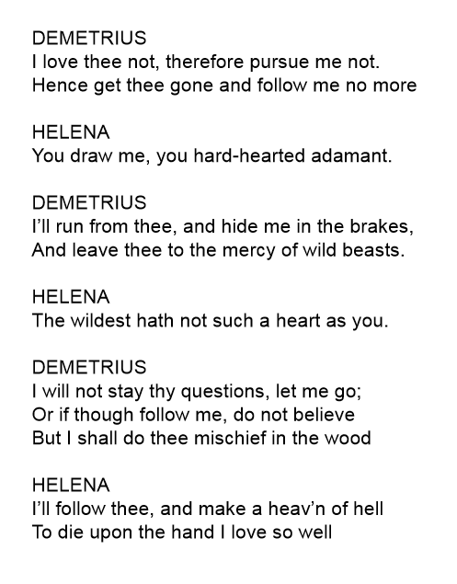
Now count out the number of syllables in the first line. How many syllables or beats are there?
Now do the same for all the other lines. What do you notice?
This regular rhythm of 10 beats per line is called iambic pentameter. Shakespeare often used this pattern in his rhyming verse.
It is very easy to write and speak in ten-beat lines, because it mirrors the way that we talk to each other on a day to day basis - eg:
I’d LIKE to HAVE aNOther CUP of TEA.
I WONder IF my FRIENDS will PLAY footBALL?
What TIME is IT? I HOPE it’s DINner TIME!
(The capitalisation shows where the stress or emphasis falls in iambic pentameter).
Now make up 5 of your own ten-beat lines about your day or hobbies.

Activity 5
We know that “A Midsummer Night’s Dream” is a comedy. Cut out the cards below and sort them into two categories:
- ‘Features of a Shakespearean comedy’
- ‘Not features of a Shakespearean comedy’

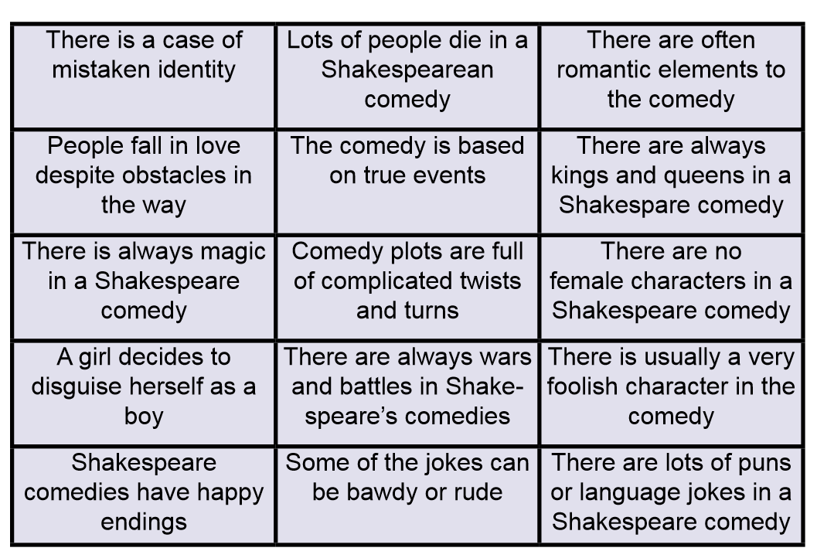
Extension Activity
- Find out more about Shakespeare’s comedies, tragedies and histories.
- How many can you research and categorise?
- What is your favourite plot?
- Which play(s) would you like to learn more about?

